# SINGLE PAGE APPLICATION

#### Sharjeel M. (BSE183003)

#### Muhammad Bilal (BSE183151)

#### M Jibran Tariq (BSE183161)



**Fall 2021-22**

**Supervised By**

**Samir Obaid**

**Department of Software Engineering**

***SPA:***

Single page application is a technique used to make web pages that don’t reload completely, only the required things in a page reloads, for example if we take example of Facebook then the navbar and sidebar doesn’t reload every time but the information that is required reloads in user’s interaction with the page. It helps to reduce redundancy of the code.

Abstract

In our project we made a simple web app that shows SPA concept using angular 12 and Visual studio MYSQL database to show data on frontend. The page doesn’t reload completely, only the certain part of the page reloads on user’s click. Our app is also responsive and uses custom navbar.

Frontend Images

***Home Page:***

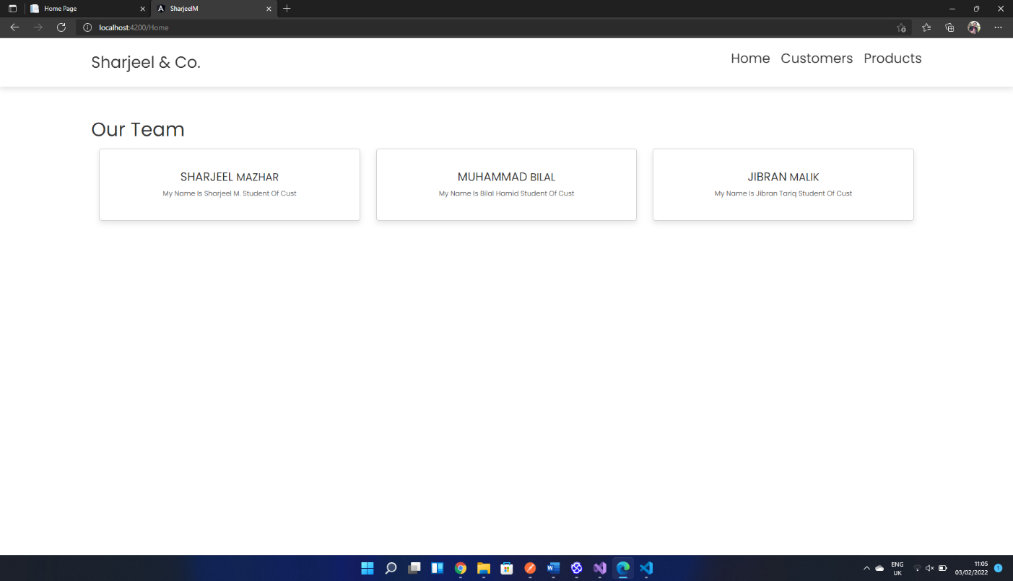

***Customer page:***

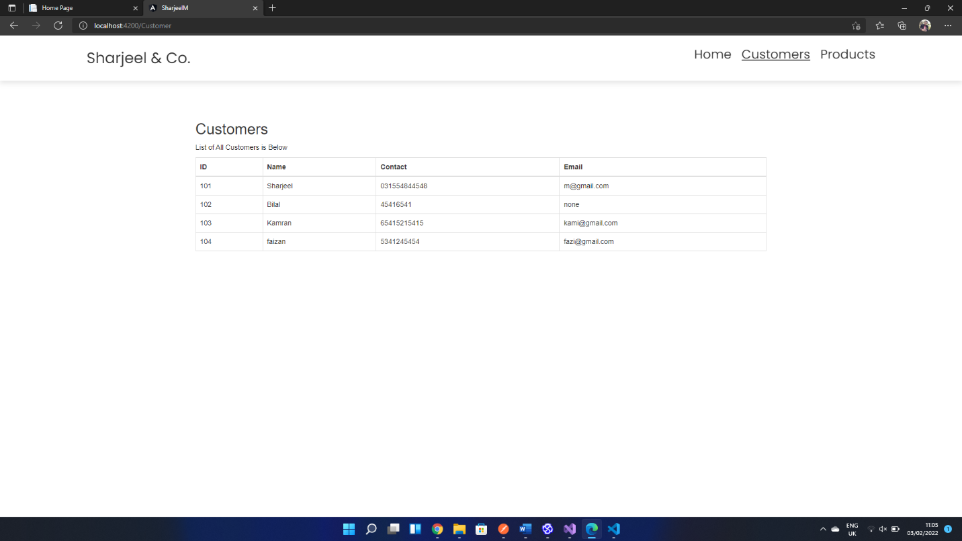

When user clicks on the customers button then only lower part of the page reloads and **data** is fetched from the **Database**, the navbar and buttons on the tops doesn’t reloads.

***Product Page:***

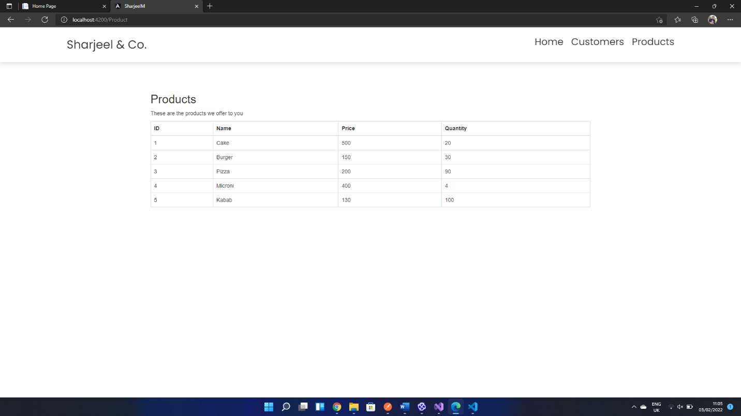

When user clicks on the products button then only lower part of the page reloads and **data** is fetched from the **Database**, the navbar and buttons on the tops doesn’t reloads.

Responsive Views

Our app is also responsive, it changes views based on the size of the screen because of styling and defining different screen sizes

Mobile View:

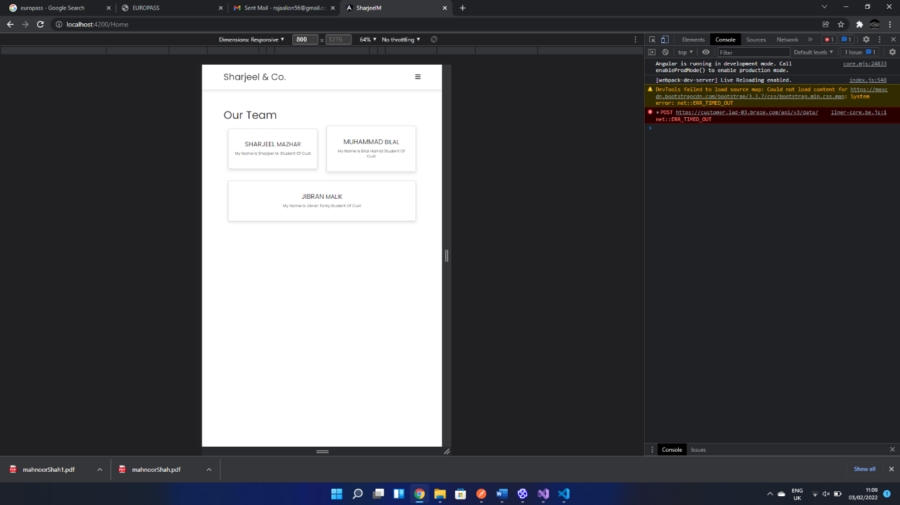

Medium View:

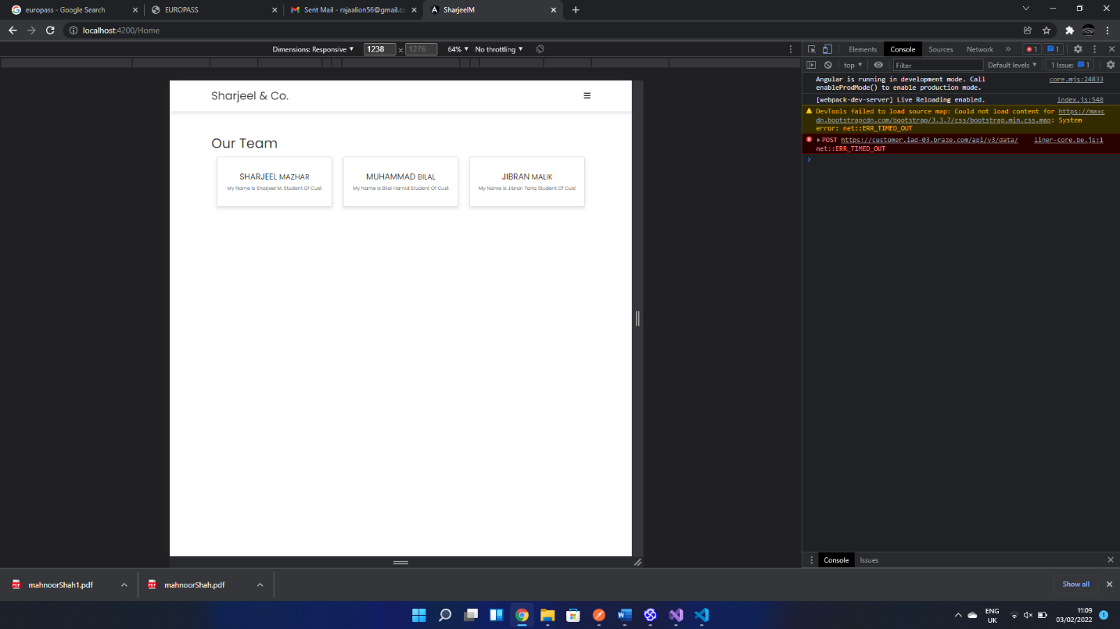

***Full View:***

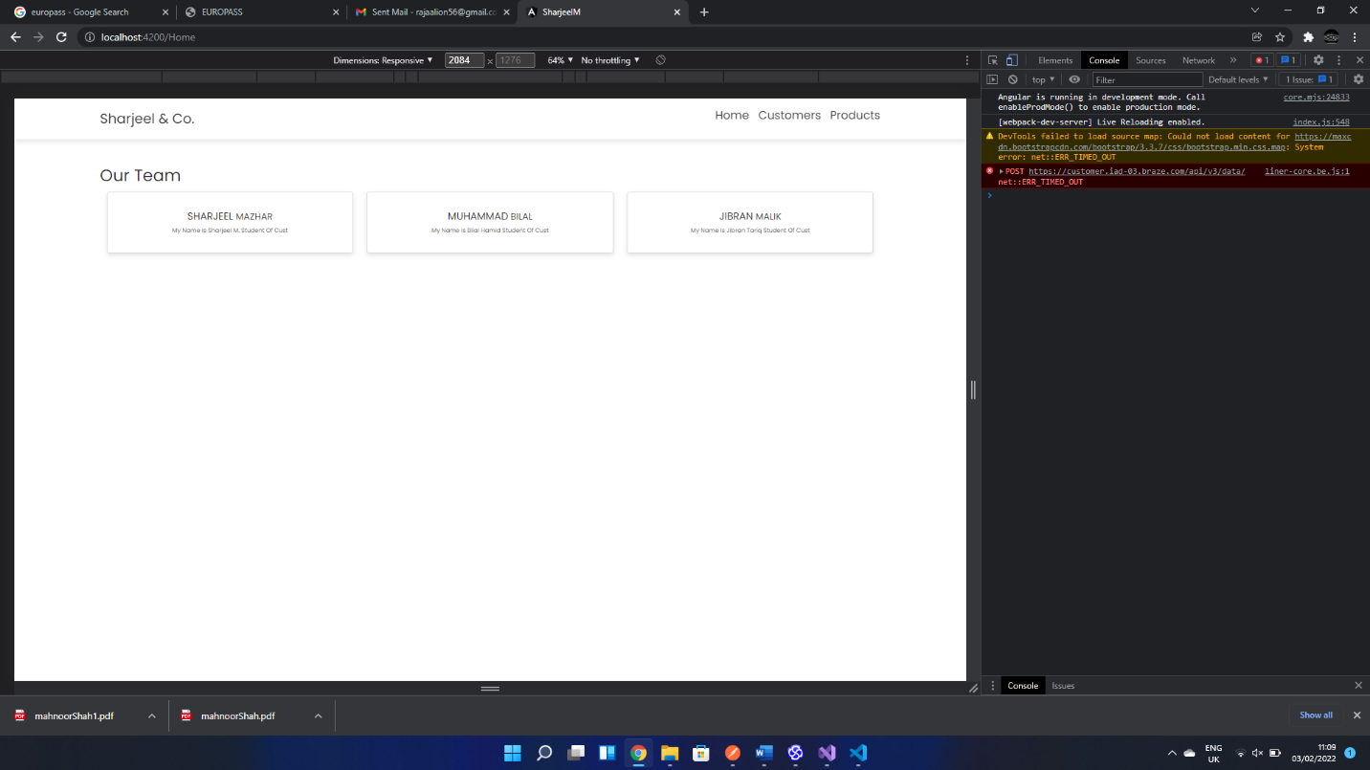

Visual Studio MYSQL DB and Get() Method

***Product Controller:***

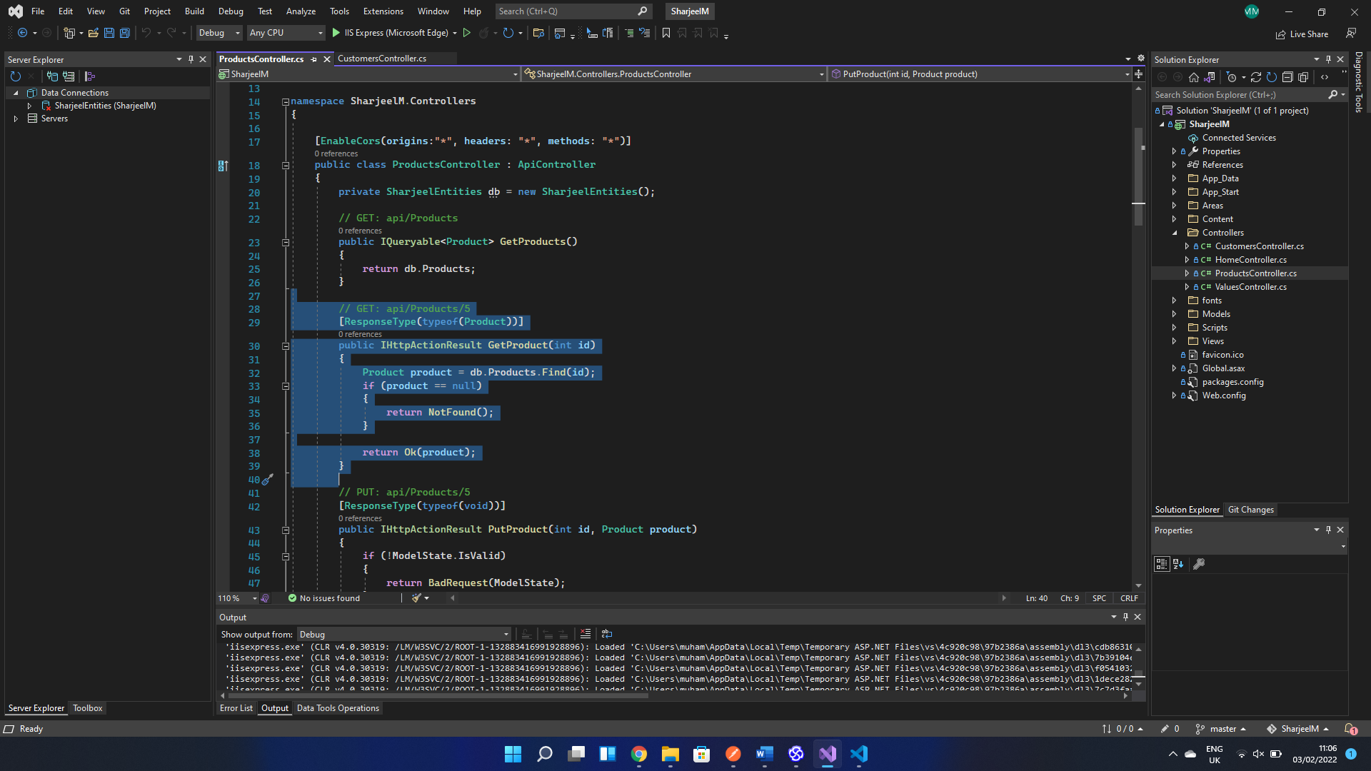

***Customer Controller:***

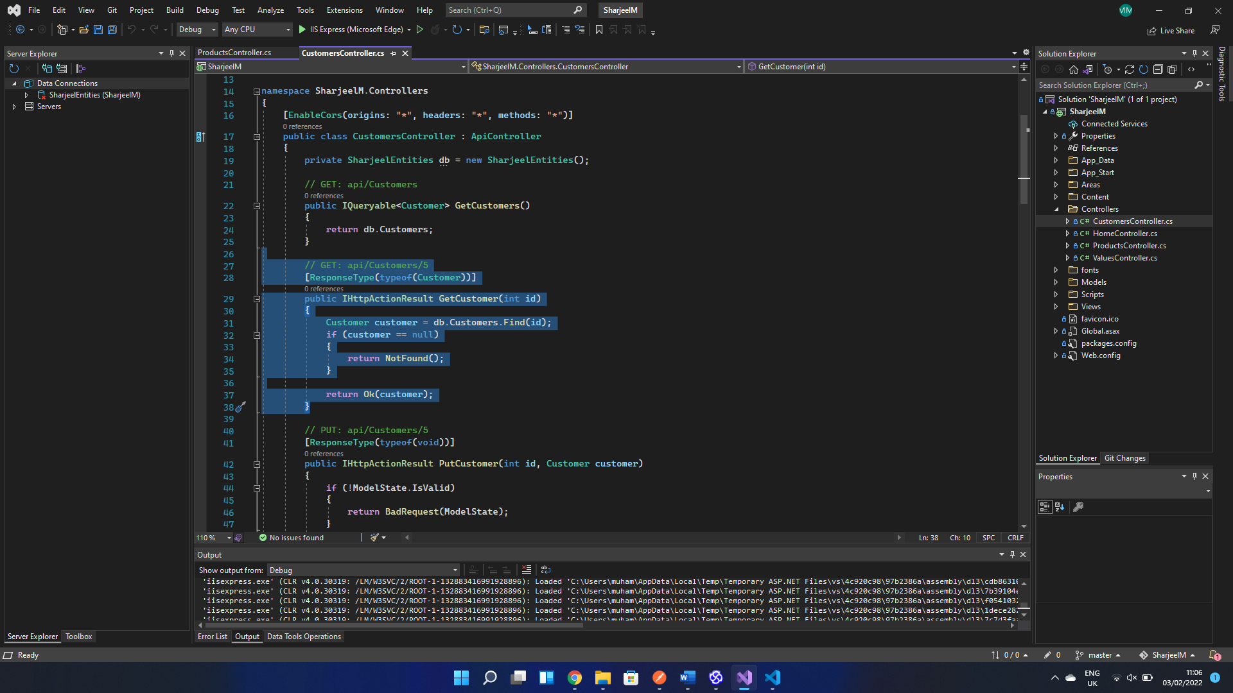

***Customer Table:***

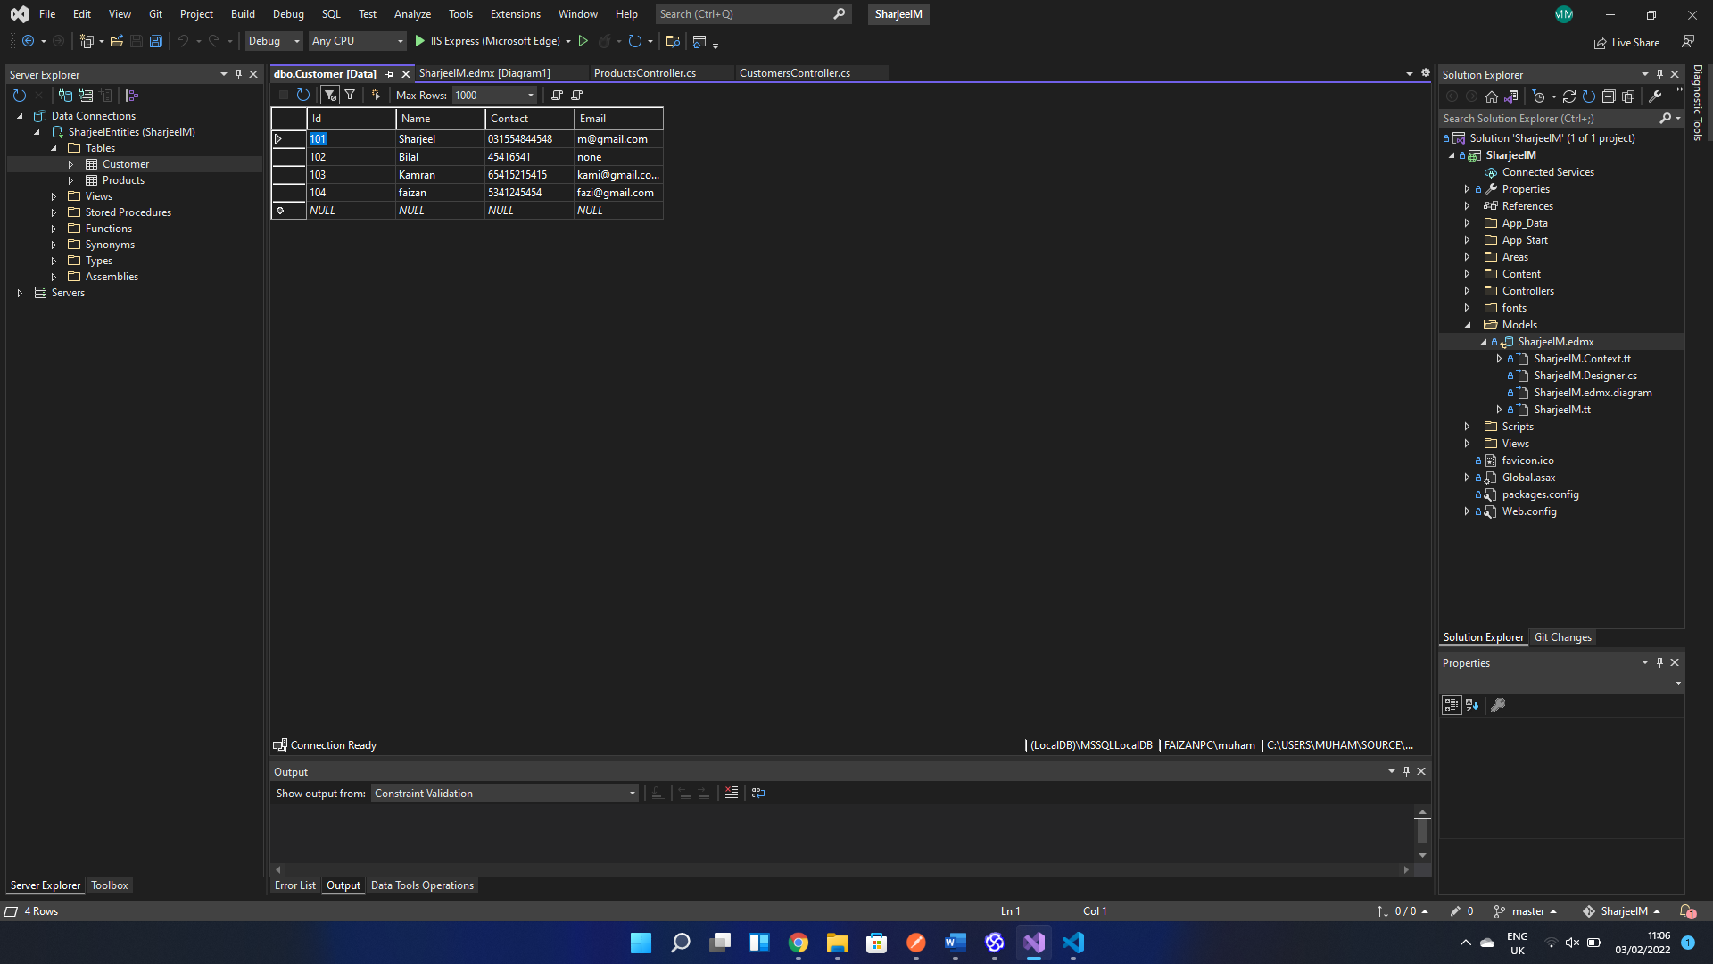

***Product Table:***

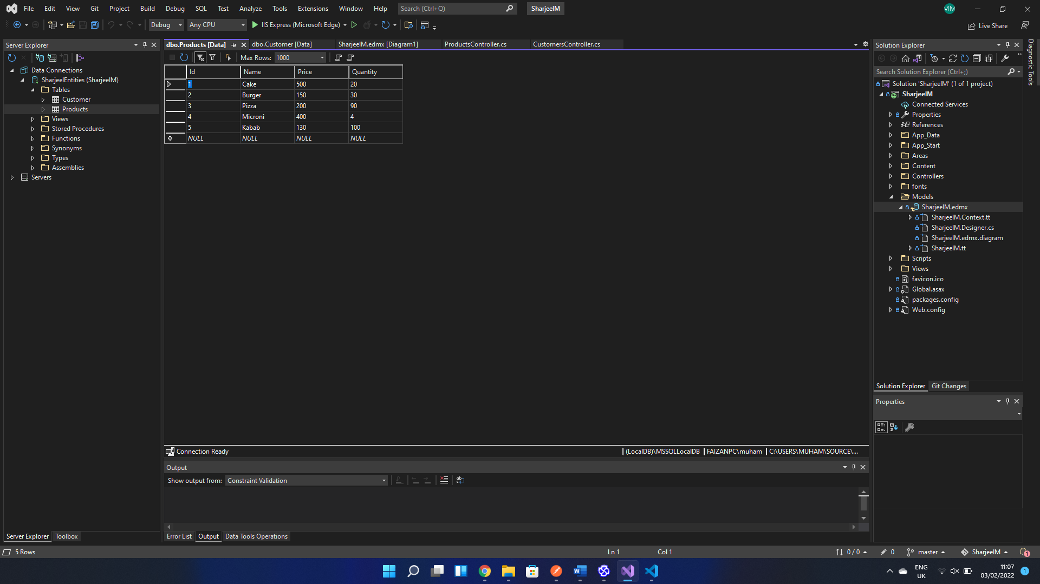

***Schema:***

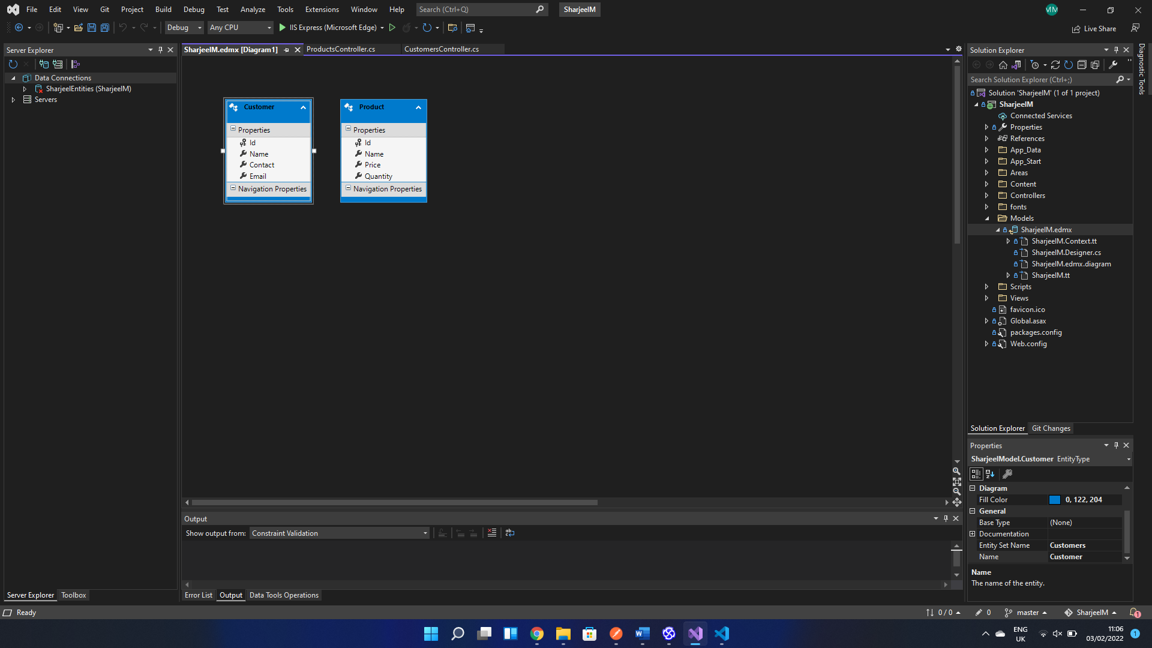

Code Screenshots for Frontend and Routing

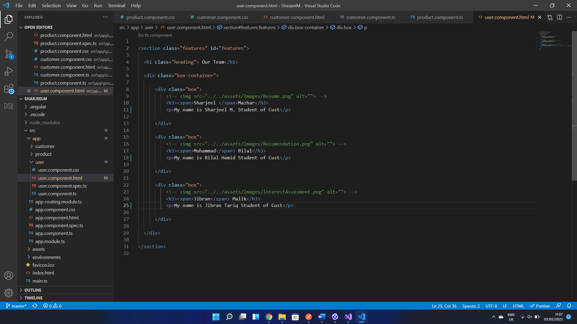

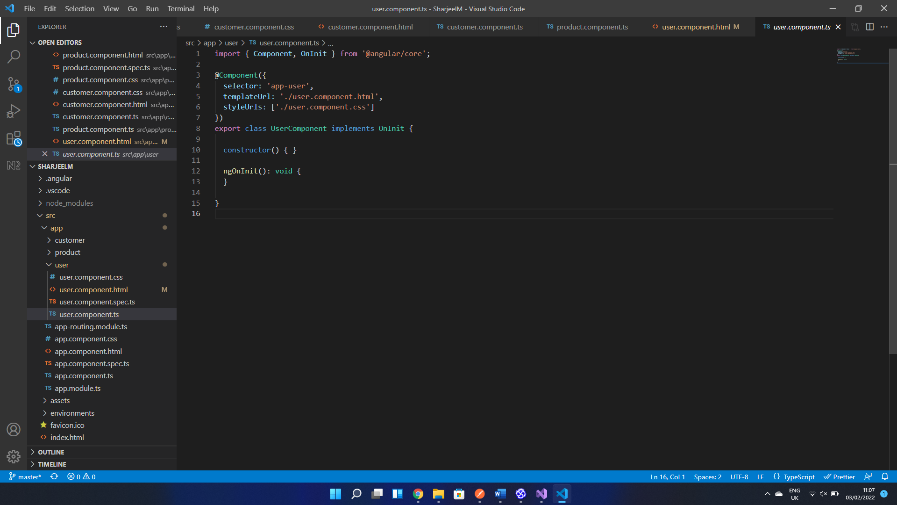

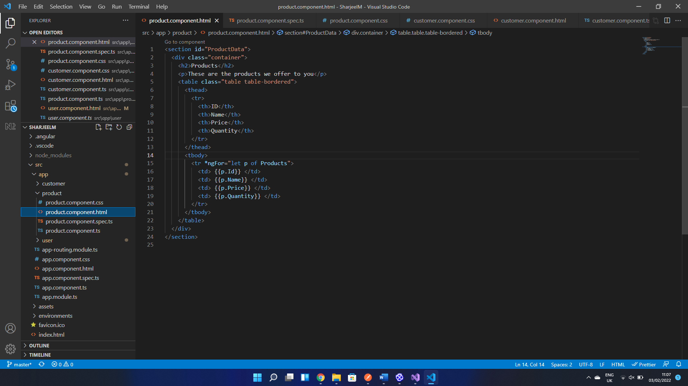

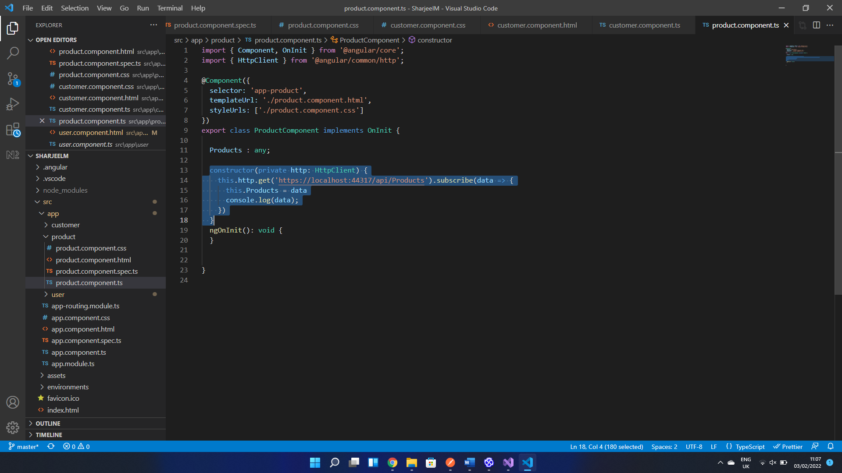

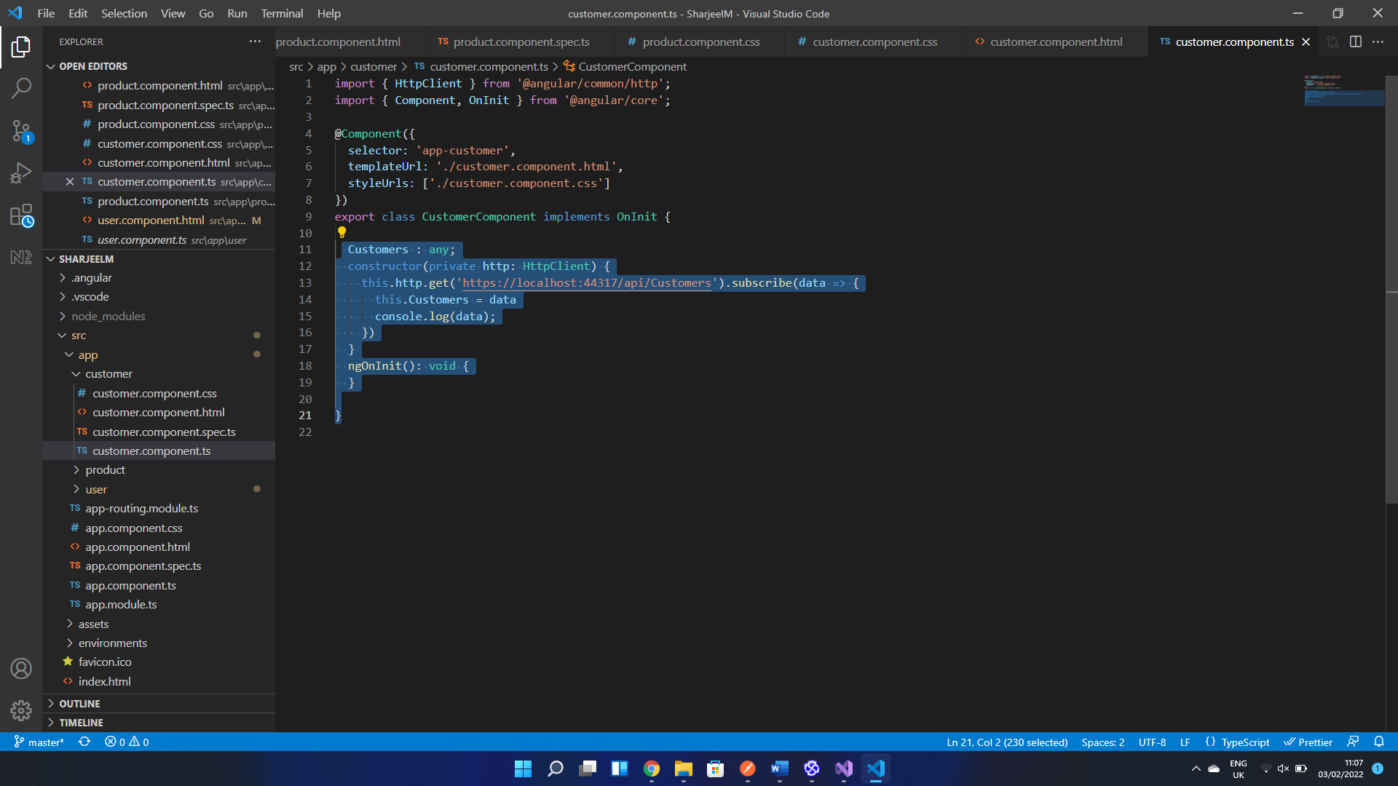

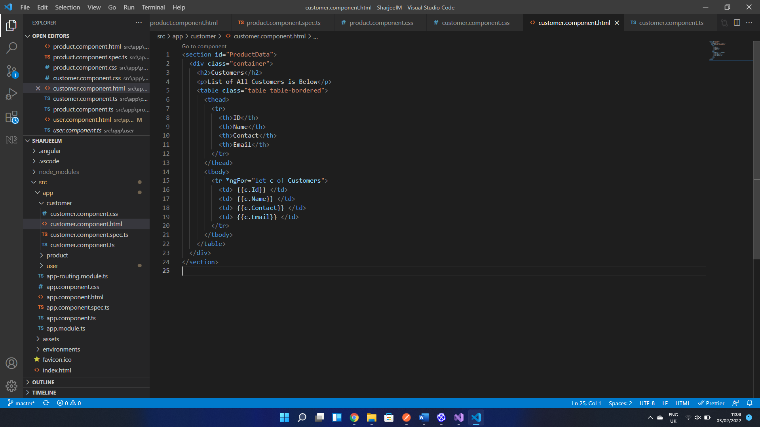

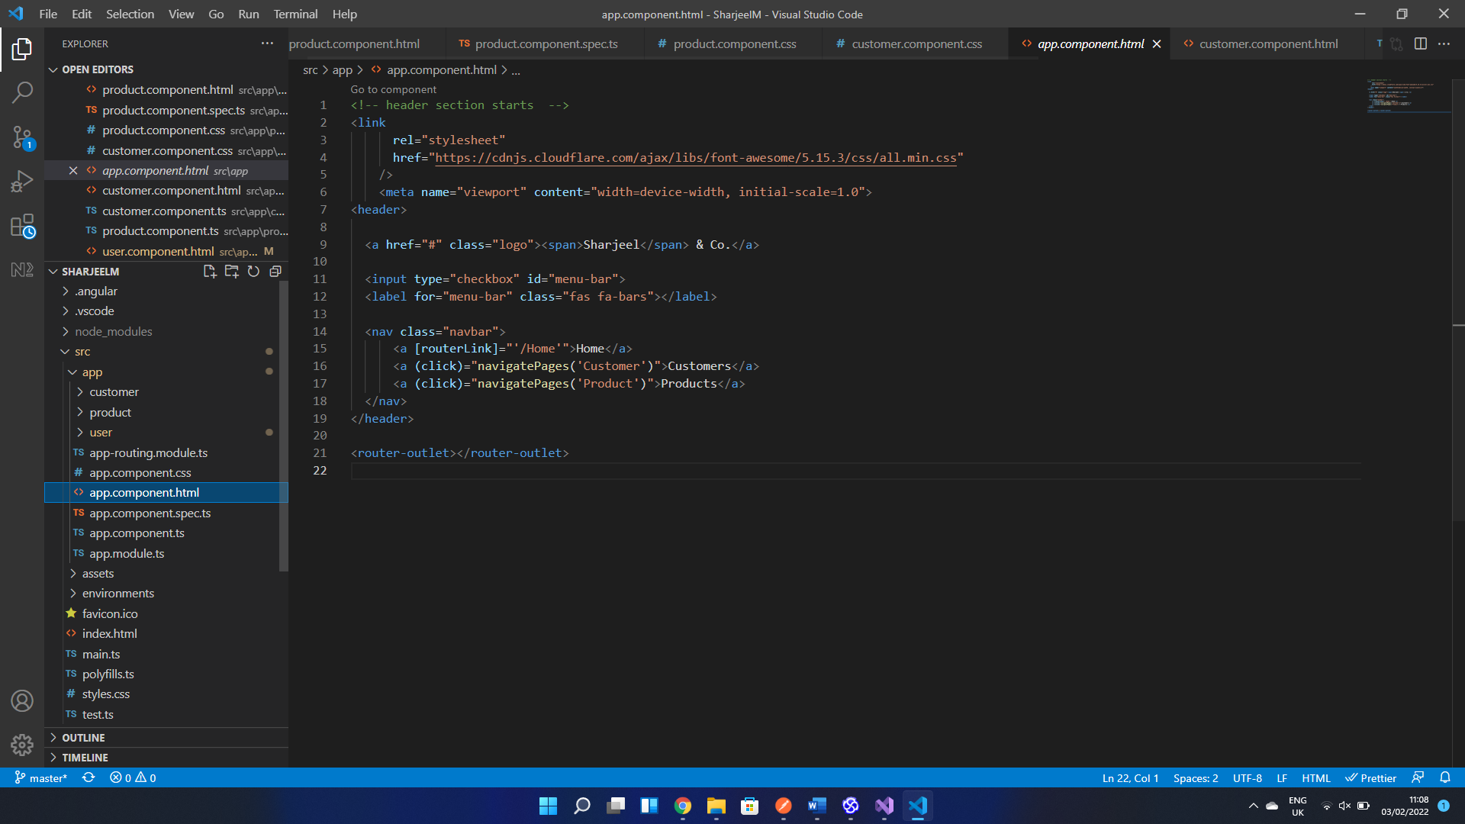

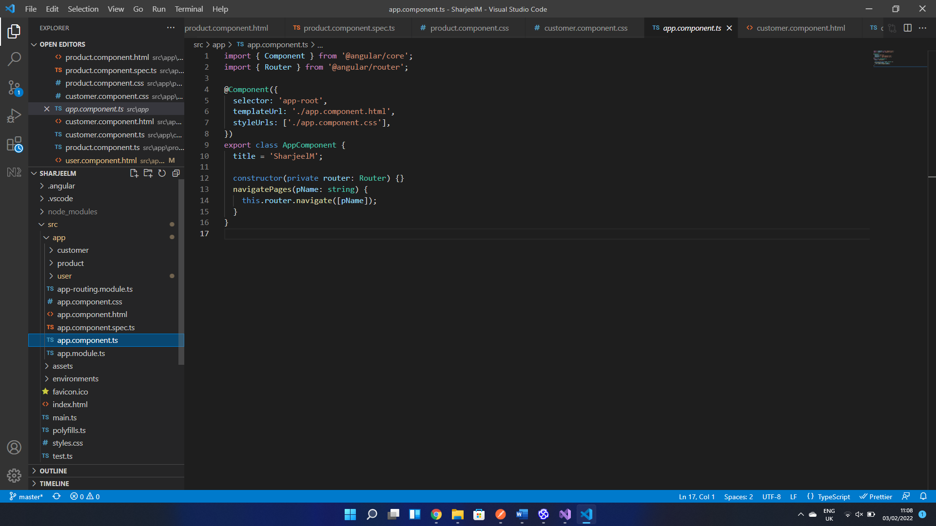

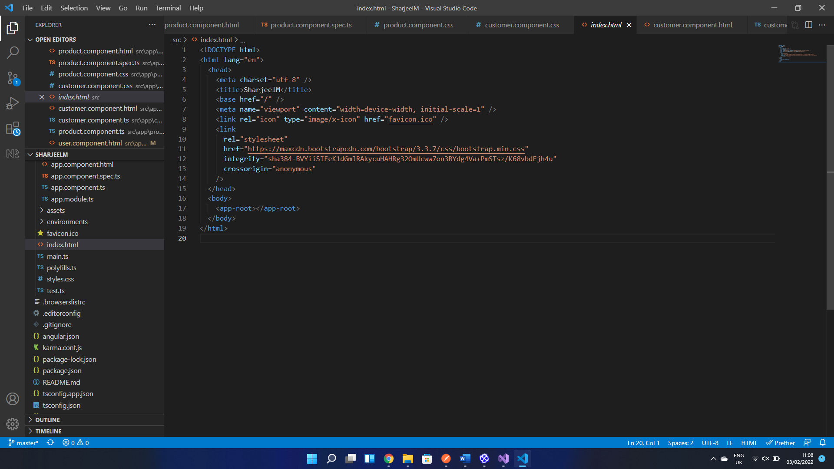

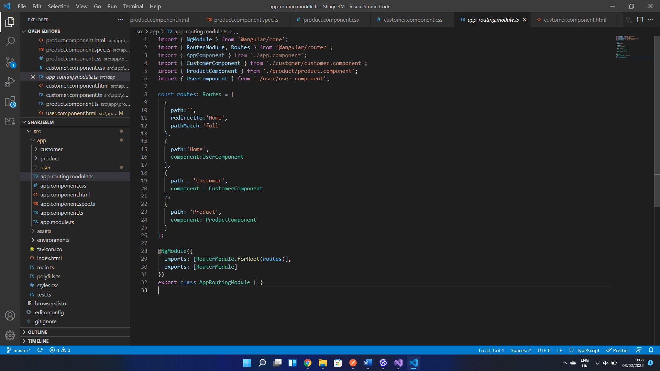

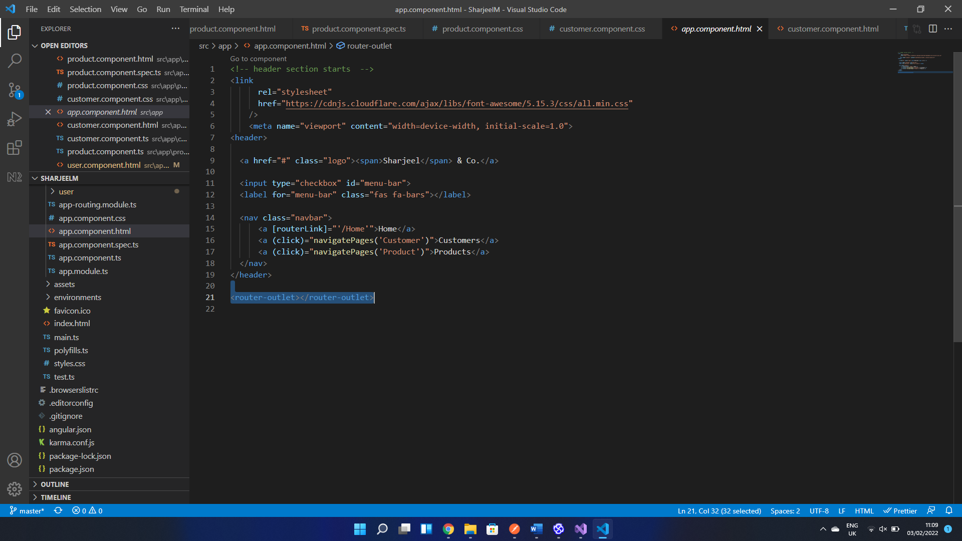

Conclusion:

In our project SPA is fully shown, no matter what user selects, the whole page doesn’t get reloaded, only some part of the page reloads. If user clicks on products then it shows the product information retrieved from the backend and if user clicks on customers then it shows the customers information retrieved from the backend.